Final Options A (300 points) & B (250 points)
Instructions: Type and double-space your answers, using 12-point Times New Roman font. Number your pages. MLA format is not required (except for the Option A SECRET). You will, however, lose points for spelling errors, serious punctuation errors, typos, and other proofreading or writing problems that interfere with readability. Answer lengths are indicated next to each section. Do not plagiarize. If you paraphrase a source or make a reference, you must provide a citation and attach a Works Cited page. Unless indicated, citations are not necessarily required for each answer. This exam includes Option A (see Part D, p. 3). The exam is due in class on the last day of class, Thursday, June 8. On page 2, I provide a sample short essay answer. I hope this is helpful. Good luck! Please indicate on your cover page whether you are doing Option A or Option B!
________________________________________________________________________________________________
OPTION A and B: Do Parts A, B, C, and D as indicated
A. Short Essay I (25 points each for Option B; 50 points for Option A)

Choose one of the following and respond briefly, with no more than one typed page (you do not get extra credit for answering more than one; if you answer more than one, I will grade only the first one you answer). Be sure to put the question number next to your answer, so I know which question you are answering!

- Discuss Louis Wirth's idea regarding "urbanism as a way of life" -- that large size, high density, and heterogeneity -- combine in an urban setting in such a way as to have dramatic results and make an argument for or against immigration controls. You may want to go to http://lcweb2.loc.gov/ammem/ndlpedu/features/immig/timeline.html to skim the various pieces of immigration and Native American legislation passed since 1786.

- Drawing from Chapter 5 in Phillips, discuss what you believe to be the best way(s) to define “community,” now that you have finished this course.

- Identify the ways in which segregation and discrimination on the one hand alienate minorities and other marginalized groups from the dominant group and on the other result in the emergence of cohesive subcommunities.

B. Short Essay II (25 points each for Option B; 50 points for Option A)

Choose one of the following and respond briefly, with no more than one typed page (you do not get extra credit for answering more than one; if you answer more than one, I will grade only the first one you answer). Be sure to put the question number next to your answer, so I know which question you are answering!

- Which internal-structure model (Burgess’s, Hoyt’s, or Harris and Ullman’s) best explains the processes and dynamics involved with gentrification? Use the best model to discuss how the process of gentrification works.

- Use Max Weber’s theories regarding status and lifestyle to discuss the notion that “you are where you live,” or, as market researchers say, “Tell me your zip code, and I’ll tell you what you eat, drink, drive – even think.”
- How do Marx’s theories regarding class and alienation help us explain some aspects of social and economic inequality in modern American cities?

C. Medium Essay (50 points)

Choose one of the following and respond briefly, with no more than one and a half typed page (you do not get extra credit for answering more than one; if you answer more than one, I will grade only the first one you answer). Be sure to put the question number next to your answer, so I know which question you are answering!

- Contrast and compare three of the most important themes from Code of the Street with those of Travesti that you think tie in best with issues we have been discussing in class. Discuss and develop these. Be sure to draw connections between these elements and specific concepts presented in the main text, City Lights, by E. Barbara Phillips.

- Contrast and compare the ethnographic methodology that Anderson uses in Code of the Street with that of Kulick in Travesti. Be sure to discuss the two works on at least three different aspects of ethnography, such as gaining entrée, participant versus nonparticipant method, subjectivity, length of time, etc. Briefly describe the ways in which these two studies shed light on the communities they look at in a way that could not be done without ethnography.
Sample Short Essay (to a made-up question)

Make-Believe Question: Define, contrast, and compare the preindustrial with the industrial city and discuss the extent to which you think these concepts are still valid today. Be sure to indicate why.

Sociologist Gideon Sjoberg first introduced the concepts of the preindustrial and industrial city in the 1960s (Phillips 90). Sjoberg’s conceptualization of the preindustrial city, also known as the “walking city,” is that it is compact and dense (generally just two miles in radius); has little land segregation; has some, but not much, separation of classes and specialization of labor; relies mostly on animate energy; tends to have an agriculturally based economy, based on barter and exchange; and, socially, has more characteristics of Ferdinand Tönnies’s Gemeinschaft model than Gesellshaft. Examples include ancient cities such as Ur and Athens, medieval cities such as Venice, and even communities in the modern era, such as primitive tribal societies in Africa. Although there has been – and continues to be – debate over what constitutes a “city,” as well as the origins of the first city, there is even more debate regarding Sjoberg’s two classifications (Phillips 92), because, as we can see, his classification of “preindustrial” seems to include everything and anything. His description of the industrial city is basically everything the preindustrial city is not: more geographically dispersed, sparsely settled (e.g., the “automobile suburb”), segregated in terms of land use (with distinct zones for industry, residences, commerce, etc.), much more class differentiation, high degrees of workforce specialization, a reliance on inanimate energy (for example, factories in the industrial era and computers in the modern era), and an economy based on monetary exchange. Although it seems to me that these two classifications clearly separate two different types of city, not only does the preindustrial category cover too much territory, but the industrial category doesn’t seem to cover enough territory. In other words, it doesn’t even begin to capture the spatial, economic, political, and social characteristics of the postindustrial (or technological) city. So, while those two categories do seem to have some use in helping us understand two ends of a spectrum, they don’t go far enough and, especially as far as the industrial classification, seem to me to be outdated.
Phillips, E. Barbara. City Lights: Urban-Suburban Life in the Global Society. New York: Oxford U Press, 1996.
D. Long Essay (150 points) [Option A: Choose only one of the following and answer it as a S.E.C.R.E.T., with all elements of a S.E.C.R.E.T., including thesis, argument, critical thinking, analysis, citations, and strict MLA formatting. If you choose this option, please so indicate very clearly.]

[Option B:] Choose any two of the following (worth 75 pts each) and respond in more detail than the Short Essays, with no more than two typed pages each (you do not get extra credit for answering more than two; I will grade only the first two you answer). Be sure to put the question number next to your answer, so I know which question you are answering! The first two questions require you to examine some political cartoons. The remaining questions follow these two.

- Examine the following political cartoon by C. J. Taylor (1889), entitled “The Mortar of Assimilation – And the One Element That Won’t Mix.” Discuss this within the context of issues such as assimilation, acculturation, discrimination, and America-the-Melting-Pot.
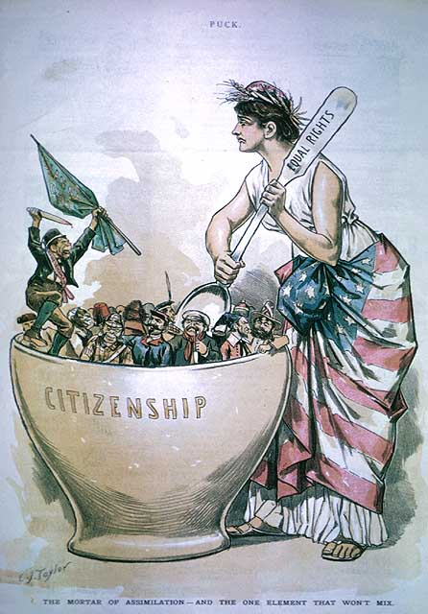
C. J. Taylor. “The Mortar of Assimilation – And the One Element That Won’t Mix.” Puck. 26 Jun. 1889. The accompanying editorial asks, “What is an American?”

- Examine the following set of political cartoons by Joseph Keppler, editor of and cartoonist for Puck magazine in the late 1800s. The first, done in 1880, is entitled “Welcome to All.” The sign to the left of Uncle Sam reads: “Free education, free land, free speech, free ballot, free lunch.” The sign near the center of the image reads: “No oppressive taxes, no expensive kings, no compulsory military service, no knouts or dungeons.” Contrast this cartoon with one that Keppler did just three years later, entitled “Looking Back.” Discuss these cartoons in the context of recent events surrounding immigration policy in the U.S.
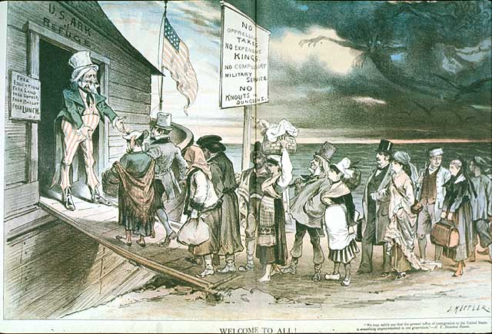 | 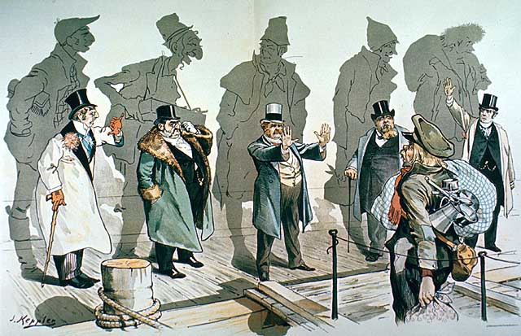
Joseph Keppler. “Welcome to All!” Puck. 28 Apr. 1880. | Joseph Keppler, “Looking Backward.” Puck. 11 Jan. 1883.
- Define and discuss the concept of clientelistic hostility as expressed in Spike Lee’s Do the Right Thing. Be sure to provide historical and sociological context: Why is there a mix of ethnicities in a community like Brooklyn? Why are there tensions? Develop the notion of the “melting pot” versus the “stewpot.”
- Define and discuss the concept of gentrification within the context of urban renewal and economic revitalization. What are its pros and cons? Can it work? If so, what will it take? If not, what is the fundamental flaw? Feel free to bring in elements from the film, NorthEast Passage.
- Discuss the concept of community in the digital age. Read Barry Wellman, “Physical Space and CyberPlace: The Rise of Personalized Networking.” 2001. <http://www.chass.utoronto.ca/%7Ewellman/publications/individualism/ijurr3a1.htm> for an overview of the more important issues and a discussion of whether or not “community” is viable in a virtual online format, divorced from physical space. Which points does he raise that you think are the most important with respect to community in the digital age?
- Louis Wirth and other urban thinkers have argued that increased population, heterogeneity, and density lead to alienation, anomie, and generalized social and psychological decay. Discuss how these arguments can be used to buttress anti-immigration legislation. In addition, consider your ecological footprint. Discuss how the arguments regarding increased population and density can be used to buttress arguments in favor of population control and strict environmental regulation. Identify the trade-offs, that is, what you feel we as a global community would be giving up or gaining if there were stricter immigration policies, population controls, and environmental regulations.

