Final Exam Part I: Course Substance and University Studies Goals Questions (60 percent)
Instructions: Type and double-space your answers, using 12-point Times New Roman font. Number your pages. MLA format is not required. You will, however, lose points for spelling errors, serious punctuation errors, typos, and other proofreading or writing problems that interfere with readability. Answer lengths are indicated next to each section. Do not plagiarize. If you paraphrase a source or make a reference, you must provide a citation and attach a Works Cited page. Unless indicated, citations are not necessarily required for each answer. Note: You may want to complete portions of this exam early and have them posted on your website for your e-portfolio presentation. The entire exam is due accessible through a single web link by noon, Friday, March 24 (for example, you might have a link to web.pdx.edu/~name/final and then have the individual sections listed separately on that page; note that you can link from other pages to sections of your final). You will receive 5 bonus points for each day it is early; to receive these bonus points, the entire exam, not just parts of it, must be complete early.

A. Short Answer (5 percent)

Choose two of the following and respond briefly, with no more than one-half typed page each (you do not get extra credit for answering more than two; if you answer more than two, I will grade only the first two you answer). Be sure to put the question number next to your answer, so I know which question you are answering!

1. Define portée and give an example from one of the readings from the last two terms.

2. Define “mysteries of iniquity” and “natural depravity” as related to the topic of our course

3. This passage from Milton’s Paradise Lost is on the title page of Mary Shelley’s Frankenstein. Why?

Did I request thee, Maker, from my clay
To mould me man? Did I solicit thee
From darkness to promote me?

4. What does Milton mean by:

“. . . Sleep on,
Blest pair; and O yet happiest if ye seek
No happier state, and know to know no more.”

B. Medium Essay No. 1 (8 percent)

Choose one of the following and respond in a bit more detail than the Short-Answer Essays, with no more than one typed page (you do not get extra credit for answering more than one; if you answer more than one, I will grade only the first one you answer). Be sure to put the question number next to your answer, so I know which question you are answering!

1. Explain how the story of Melville’s Billy Budd relates both to “forbidden knowledge” and to ethics (consult the Ethics rubric).

2. Charles Darwin wrote, “It is wonderful what the principle of Selection by man, that is the picking out of individuals with any desired quality, and breeding from them, and again picking out, can do. Even Breeders have been astonished at their own results. . . . Man by this power of accumulating variations adapts living beings to his wants – he may be said to make the wool of one sheep good for carpets and another for cloth . . . .” (Charles Darwin's Letters: A Selection 1825-1859, 178). Discuss the contradictory ethical and “forbidden knowledge” ramifications of this quote with respect to science and the theory of evolution, eugenics, and the controversy of cloning. Again, be sure to consult the Ethics rubric.
C. Medium Essay No. 2 (12 percent)

For each of the following types of forbidden knowledge as described in Shattuck, select and discuss one book or article we read this term that you feel best relates to or expresses the type of forbidden knowledge. Be sure to explain how and why the reading you chose is relevant. You should discuss a different reading for each type of forbidden knowledge. Write no more than one and one-half pages total (approximately one-half page per type). Include citations as appropriate.

- Inaccessible, unattainable knowledge
- Knowledge prohibited by divine, religious, moral, or secular authority
- Dangerous, destructive, or unwelcome knowledge

D. Long Essay No. 1 (20 percent)

Examine the University Studies goals and their rubrics at http://www.pdx.edu/unst/goals.html. Explain in a paragraph or so what each goal means to you. Follow each paragraph with a reflective essay regarding a different project, film, or reading from this term that best exemplifies your mastery so far of the goal. You may reference works and projects that you did but perhaps did not turn in or get graded (for example, something turned in late and not accepted). Think of this as what you would like to showcase on your web site as an example of your understanding of each goal. Separately address writing and quantitative literacy under the communication goal. Limit this discussion to four pages total.

E. Long Essay No. 2 (15 percent)

Examine one of the following six pieces of art and write a reflective essay revealing what that piece says about forbidden knowledge. Attempt to use this opportunity to reflect your grasp of as many of the goals as possible (with the exception of QL). Limit your discussion to two or three pages. Include citations as necessary. This would probably be a nice addition to your website. You can copy and paste the picture you decide to use directly on to your website. Be sure to label it. All works here are public domain, so you do not need permissions.

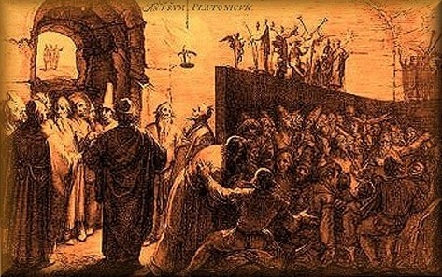
1. Plato’s Cave, by Jan Saendredam (1604)

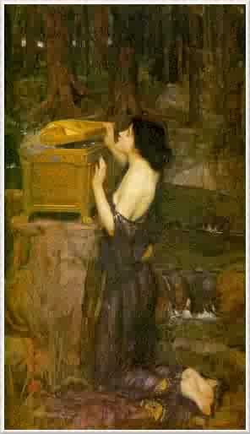
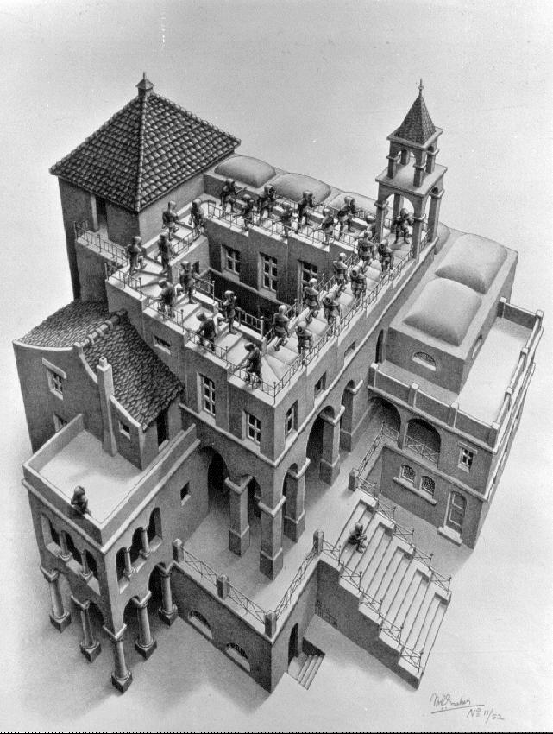
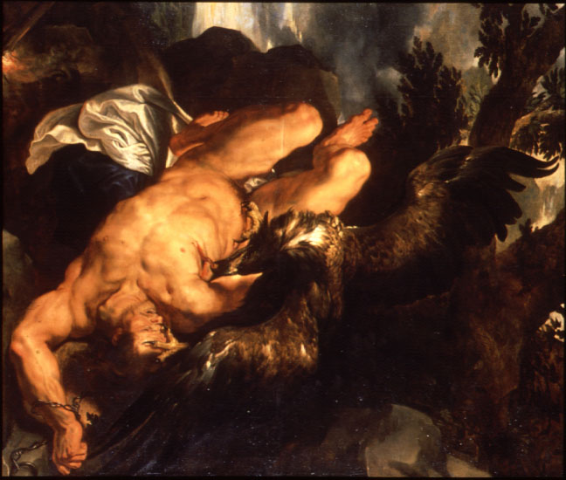
2. M. C. Escher, Ascending and Descending (1960) 3. Pandora’s Box, John William Waterhouse, 1849-1917
4. Ruben’s Prometheus Bound, 1611-1612

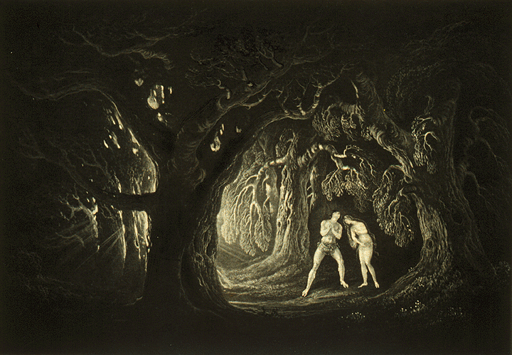
5. John Martin, Book X, Paradise Lost

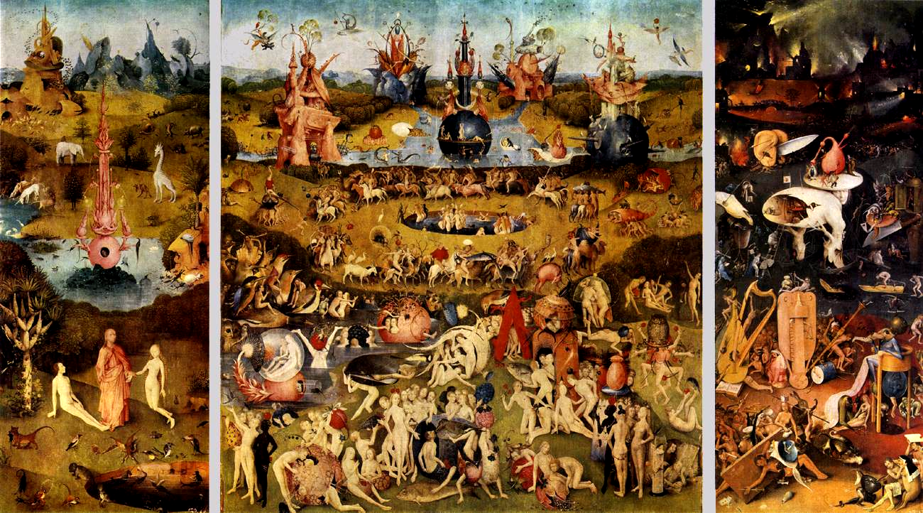
6. Hieronymous Bosch, Garden of Earthly Delights (ca. 1500)

