WEEK 43

Write the microtheme at the end of this week’s packet. You’ll be asked to do additional work on the microtheme after today’s lesson. When you are finished, please carefully tear off the microtheme section and turn it in.

WRITING TOPIC: The Writing Process – Stage 3.s

I. THE PROCESS SO FAR: CPrewriting + Outlining + First Draft Writingn
- Topic selection and prewriting
- Topic sentence and outlining
- Writing / Revising / Editing

II. FROM OUTLINE TO FIRST DRAFT
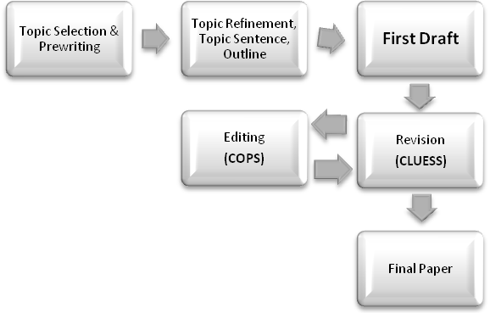
III. REVISION & EDITING
- REVISION: Use CLUESS (pronounced “clues”)
  - Coherence
  - Language
  - Unity
  - Emphasis
  - Support
  - Sentences
- EDITING: Use COPS
  - Capitalization
  - Omissions
  - Punctuation
  - Spelling
IV. TOOLS AND PROCEDURES

A. Take Advantage of Your Word Processor
- Spell and grammar check
- Thesaurus

B. How to Proofread & Edit
- Run your spell and grammar check
- Proofread your paper on the screen
- Wait at least half an hour and then print out your paper and proofread the hard copy; make corrections
- Run another spell and grammar check (why?)
- Wait at least half an hour and then print out your paper and read it out loud.
- If you are especially prone to errors, read out loud backwards.
- Ask a friend/relative to read your paper in addition to, but not instead of your reading it!

C. Review Instructor Feedback
- Refer to the Correction Chart in the back of your book
- Note most frequent errors and refer to the book to review those concepts
- Revisit the online quiz on that chapter if you still need practice

D. Grading Rubric
- Go over your paper according to the grading rubric

E. Writing Guidelines
- Always follow the Writing Guidelines
- Header with course & instructor info, your name, due date, page number, and assignment title
- 1” margins all around
- Typed, with 12-point Times New Roman font
- Right alignment, not “justified”
- Double spaced, with ½-inch indentation at the beginning of each paragraph

CCLUESSS

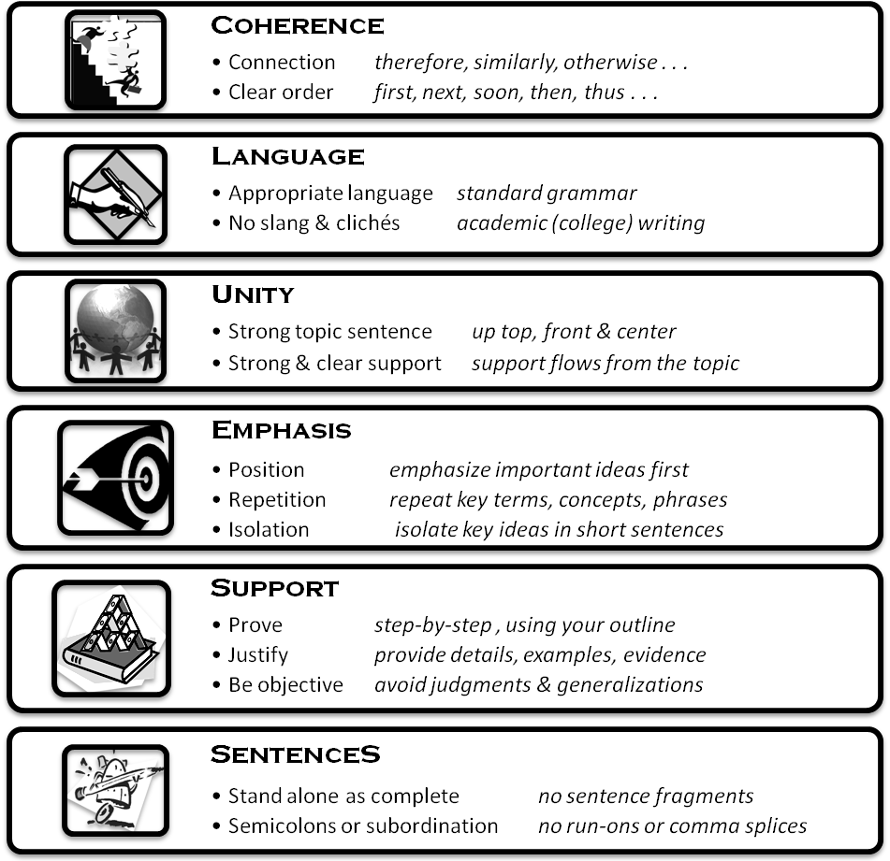

CCOPSS
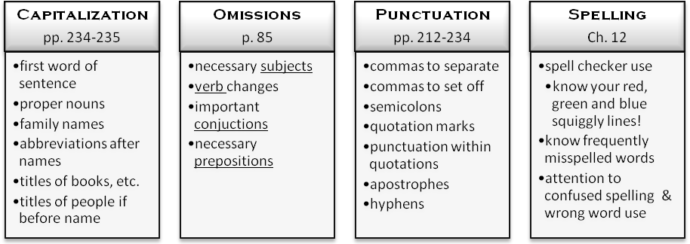


Write the microtheme below. You’ll be asked to do additional work on the microtheme after today’s lesson. Write small enough so that you can fit 80-100 words in the box, but if you need to, attach another piece of paper. When you are finished, please carefully tear off the microtheme section and turn it in.

Write a microtheme of 80 to 100 words a problem you’ve had with school business, either this term or in the past. This could have to do with scheduling, counseling or advising, student activities, financial aid, parking, expenses, etc. Provide at least one example and either tell how you solved it or suggest a solution.
Name Name_______________________________________

